**Experiment 26**

**AIM :**

To design DFA in which ‘a’ appears tripled of b in automata.

**Design and output:**

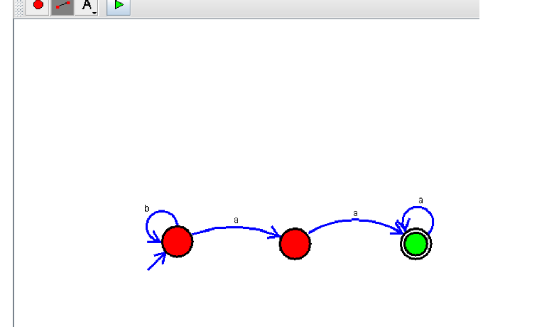

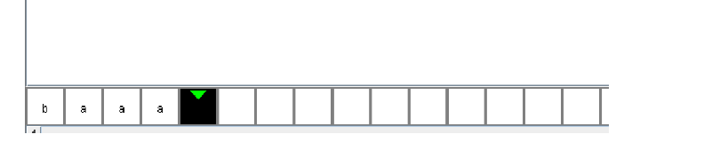

**Result:** Thus designing DFA in which ‘a’ appears tripled of b is done and verified by giving sample inputs.